A Hybrid Ensemble Framework for Intrusion Detection and Attack Classification Using Random Forest, Kernel PCA–K-Means, and XGBoost

Group 3 - Kalyan Brata Majumder, Karthik Mekala and Kunal Gurtoo
Supervisor - Professor Anamika Singh
Department of Applied Artificial Intelligence, University of San Diego

Github Link-

Acknowledgement

We would like to express our sincere gratitude to our project guide, Prof. Anamika Singh, for her invaluable guidance, constructive feedback, and continuous support throughout the course of this project. Her insights on structuring the technical report and suggestions for enhancing the project’s future scope have been instrumental in shaping the overall quality of our work.
We would also like to acknowledge the collaborative efforts of our team members.
Kalyan Brata Majumder extensively contributed to this project in designing and developing the hybrid intrusion detection framework. He implemented the binary Random Forest classifier for attack detection, performed feature selection using feature importance analysis, and developed the Kernel PCA + K-Means clustering model to improve unsupervised traffic classification. He integrated supervised and unsupervised outputs into a stacked ensemble architecture and designed the final XGBoost-based hybrid model. Additionally, he conducted model evaluation, comparative analysis, feature engineering, hyperparameter tuning, and performance optimization to improve intrusion detection accuracy and robustness.
Karthik Mekala significantly contributed in identifying and grouping attack categories in a manner that reduced class imbalance and improved the effectiveness of multiclass classification. He also developed the attack category encoding framework, enabling downstream machine learning models to train and predict effectively. Additionally, he created the baseline PCA + K-Means model, which served as an important benchmark for evaluating the proposed Kernel PCA + K-Means approach.
Kunal Gurtoo contributed to the attack-type classification component of this project. He played a key role in designing the multiclass prediction framework and incorporating attack-category probability outputs into the hybrid ensemble architecture. His work enabled the model to leverage attack-specific probability distributions as additional intelligence for the final XGBoost classifier, improving both predictive capability and attack attribution within the intrusion detection system.
Finally, we would like to acknowledge the availability of the CICIDS2017 dataset and related resources, which provided a strong foundation for conducting this research. The collective effort, collaboration, and knowledge sharing among team members have been essential in successfully completing this project.

Contents

- Introduction 5
- Literature Review 5
- Data Summary
  - Dataset Description 6
  - Data Pre-Processing 6
  - Major challenges in Network Distribution Labels 7
  - Correlation Analysis of Numerical Features 8
  - Binary Label Encoding 8
  - Train–Test Split and Class Imbalance Handling 9
- Methodology 9
  - Model 1: Supervised Learning Approach (Random Forest) 10
    - System Overview 10
    - Model Evaluation and Result 11
  - Model 2: Unsupervised Learning Approach(K-Means Clustering) 14
    - System Overview 14
    - Model Evaluation and Result 15
    - Conclusion 17
  - Model 3: Supervised Learning Approach (XGBoost) 17
4.3.1 System Overview 17
4.3.2 Model Evaluation and Result 19
4.3.3 Important Consideration: Near Perfect Performance 21
5. Conclusion 21
6. Limitations and Future Scope 22
7. References 23

List Of Figures
S.No. | Figure No. | Figure Caption | Page No.
1. | 3.3 | Distribution of network table labels | 7
2. | 3.4 | Correlation Features | 8
3. | 4 | System Architecture of the Proposed Model | 9
4. | 4.1.2.1 | Classification Report (Supervised Model-Random Forest) | 11
5. | 4.1.2.2 | Confusion Matrix (Supervised Model-Random Forest) | 12
6. | 4.1.2.3 | ROC Curve (Supervised Model-Random Forest) | 12
7. | 4.1.2.4 | Top 15 Feature Importance (Supervised Model-Random Forest) | 13
8. | 4.1.2.5 | Learning Curve (Supervised Model-Random Forest) | 13
9. | 4.2.1.7 | K-Means Clustering in PCA Space | 15
10. | 4.2.2.1 | K-Means Classification Report (Unsupervised Model) | 15
11. | 4.2.2.2 | K-Means Confusion Matrix (Unsupervised Model) | 16
12. | 4.2.2.3 | K-Means ROC Curve (Unsupervised Model) | 16
13. | 4.3.1.1 | Integration of Data Set | 18
14. | 4.3.2.1 | Classification Report of XGBoost Model | 19
15. | 4.3.2.2 | Confusion Matrix (XGBoost Model) | 19
16. | 4.3.2.3 | ROC Curve (XGBoost Model) | 20
17. | 4.3.2.4 | Learning Curve (XGBoost) | 20
18. | 4.3.2.5 | Top Selected Feature (XGBoost) | 21
19. | 5 | Schematic Diagram of Hybrid IDS | 22

1. INTRODUCTION
Modern network environments generate massive volumes of traffic, making the identification of malicious activities increasingly challenging. While detecting whether traffic is benign or malicious remains a fundamental requirement of Intrusion Detection Systems (IDS), security analysts also require information about the nature of an attack to support effective incident response and threat mitigation.
This project proposes a Hybrid Ensemble Intrusion Detection and Attack Classification Framework that combines supervised, unsupervised, and ensemble learning techniques to improve network security. The framework integrates Random Forest-based intrusion detection, Kernel PCA + K-Means clustering, and multiclass attack categorization to identify both malicious traffic and specific attack families. The outputs of these models are combined within an XGBoost ensemble classifier, enabling the system to leverage traffic behavior, attack-type intelligence, and structural network patterns. Using the CICIDS2017 dataset, the proposed approach provides accurate intrusion detection along with attack attribution capabilities for enhanced cybersecurity operations.
- LITERATURE REVIEW

The CICIDS2017 dataset has emerged as a prominent benchmark for evaluating machine learning-based intrusion detection systems due to its realistic traffic profiles and diverse attack scenarios [1]. Supervised algorithms, particularly Random Forest and XGBoost, have demonstrated strong classification performance, while feature selection and dimensionality reduction techniques have been employed to enhance efficiency and mitigate redundancy [2], [4], [6], [7].
Recent research has increasingly focused on hybrid architectures that integrate clustering and classification to capture both explicit and latent traffic characteristics [3]. Nonlinear transformation methods such as Kernel PCA have further improved data representation by preserving complex network behaviors that may not be captured through conventional linear techniques [8]. In parallel, ensemble learning strategies have shown effectiveness in improving predictive robustness through the integration of multiple learning paradigms [5], [10].
Despite these advances, existing studies predominantly emphasize binary intrusion detection. This work extends current research by combining attack categorization, nonlinear clustering, and ensemble learning within a unified framework, thereby enhancing both detection capability and attack attribution [9].

- DATA SUMMARY
  - Dataset Description
- [1], The study uses the CICIDS2017 dataset from Kaggle, containing labelled network traffic with multiple attack types and 78 flow-based features suitable for machine learning.
- The dataset was generated in a realistic testbed environment at the Canadian Institute for Cybersecurity, capturing both benign and malicious traffic.
- Data collection spans five days, including one fully benign day and multiple days with attacks such as DoS, DDoS, brute force, web attacks, botnet, and infiltration.
- The dataset reflects modern network behaviour and is widely used for intrusion detection research as a replacement for older datasets.
- Some limitations include class imbalance, label noise, and redundant or irrelevant flows, which require preprocessing.
3.2 Data Pre-Processing
- Cleaning negative values – Negative or invalid values were handled by removing a few records and replacing others with zero to avoid excessive data loss.
- Column consistency check – Ensured all CSV files had identical column structure before merging to prevent data misalignment.
- Removal of infinite values – Infinite values arising from division-based features were identified and removed to ensure stable model training.
- Duplicate column removal – Redundant or duplicate columns were eliminated to improve data quality and reduce dimensionality.

  - Major challenges in Network Distribution Labels
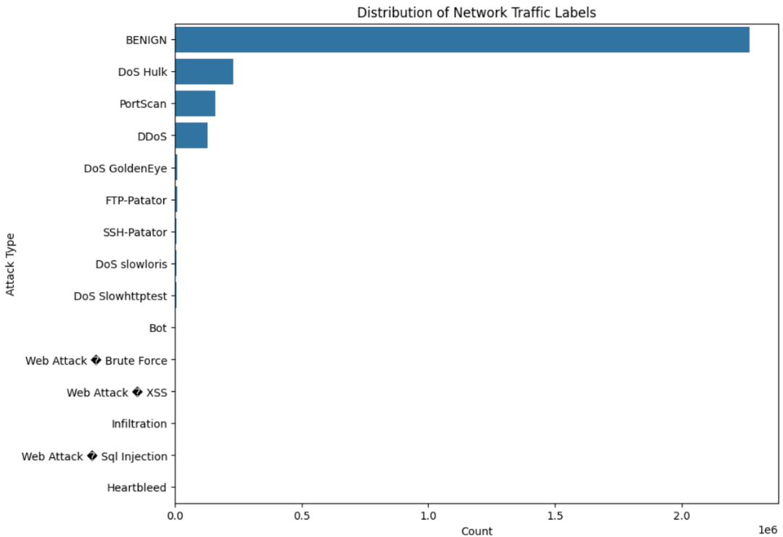
Fig 3.3: Distribution of network table labels

The figure shows a highly imbalanced dataset, where BENIGN traffic overwhelmingly dominates. Among attacks, DoS Hulk, Port Scan, and DDoS appear more frequently, while others like Heartbleed, SQL Injection, Infiltration, and Web Attacks have very few samples.
This imbalance can bias the model toward predicting the BENIGN class.
Rare attack types may not be effectively learned by the model.

  - Correlation Analysis of Numerical Features

The analysis identified several highly correlated and redundant features. Removing them reduced dimensionality, improved training efficiency, minimized overfitting, and enhanced interpretability.
Overall, correlation-based feature selection which we will see in the following section, streamlined the dataset while retaining important information, resulting in a more efficient and robust feature set for model training.

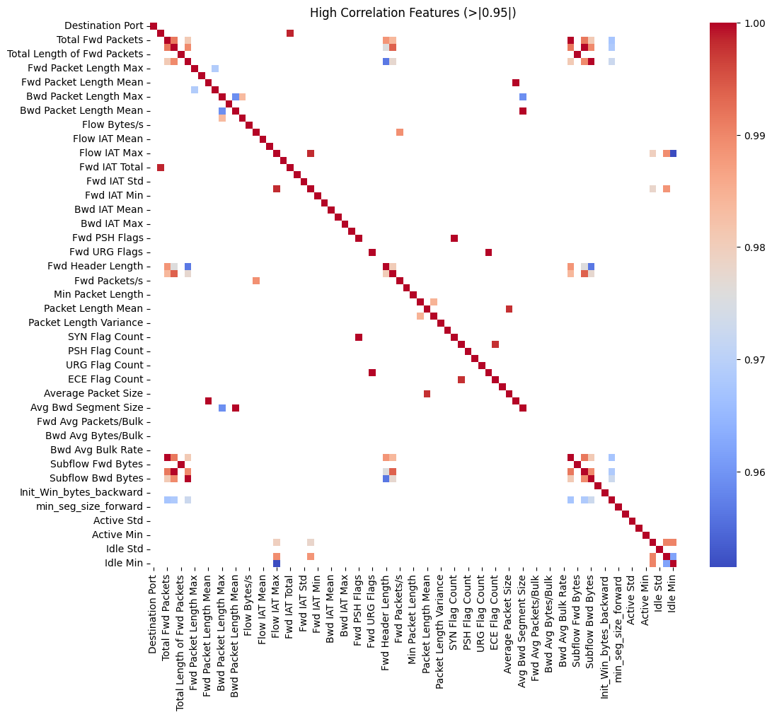

Fig 3.4: Correlation Features

3.5 Binary Label Encoding
The dataset is converted into a binary classification problem by encoding BENIGN traffic as 0 and all attack types as 1. Labels are first standardized (trimmed and uppercased) for consistency. This simplifies the task and aligns with practical intrusion detection systems.
3.6 Attack Category Consolidation and Encoding
3.6.1 Objective
To reduce class fragmentation and create a more meaningful multiclass classification problem, the original CICIDS2017 attack labels were consolidated into six high-level attack categories and encoded into numerical values using LabelEncoder.
3.6.2 Attack Category Encoding
Original attack labels were mapped to their corresponding attack categories and subsequently converted into numerical values using Scikit-learn's LabelEncoder. The encoded labels were used as target variables for multiclass attack classification.

Attack Category | Encoded Class
Benign | 0
Credential_Attack | 1
DoS_DDoS | 2
Malware_Compromise | 3
Reconnaissance | 4
Web_Attack | 5

3.6.3 Category Distribution
Following consolidation, the dataset distribution was:
Attack Category | Count | Percentage
Benign | 2,268,589 | 80.31%
DoS_DDoS | 379,554 | 13.44%
Reconnaissance | 158,804 | 5.62%
Credential_Attack | 15,333 | 0.54%
Malware_Compromise | 1,998 | 0.07%
Web_Attack | 673 | 0.02%

Total records: 2,825,951

3.6.3 Distribution Analysis
Figure X illustrates the distribution of attack categories after excluding benign traffic. The DoS_DDoS category dominates the attack dataset, followed by Reconnaissance traffic. In contrast, Credential_Attack, Malware_Compromise, and Web_Attack categories contain significantly fewer samples, indicating substantial class imbalance. Despite this imbalance, the consolidated taxonomy provides a more interpretable attack representation while reducing the complexity of multiclass intrusion detection.

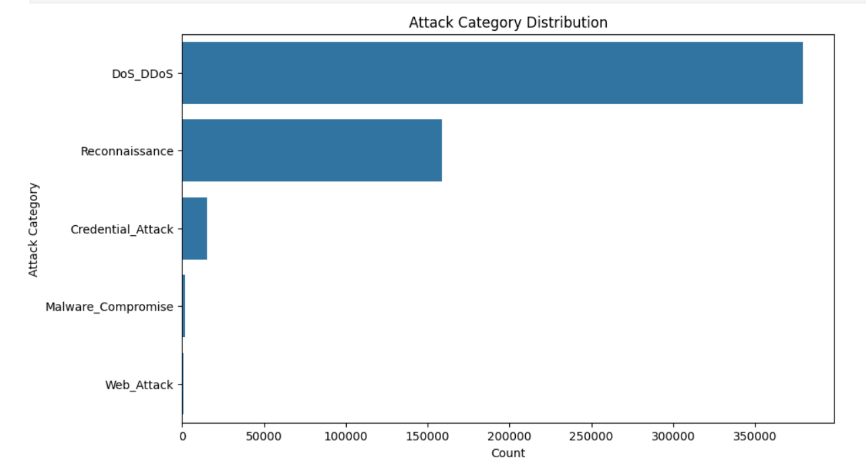
3.6.4 Key Outcome
The encoded attack categories were used to train a multiclass attack classification model. The predicted attack classes and their corresponding probability scores were subsequently incorporated as meta-features in the final hybrid intrusion detection framework.

3.7 Train–Test Split and Class Imbalance Handling
The dataset is imbalanced, with benign traffic dominating attack instances. Stratified sampling is used to split the data while preserving class distribution.
Under sampling is applied only to the training set to balance classes and avoid data leakage. This ensures improved detection of attack traffic while maintaining realistic evaluation conditions.

- METHODOLOGY
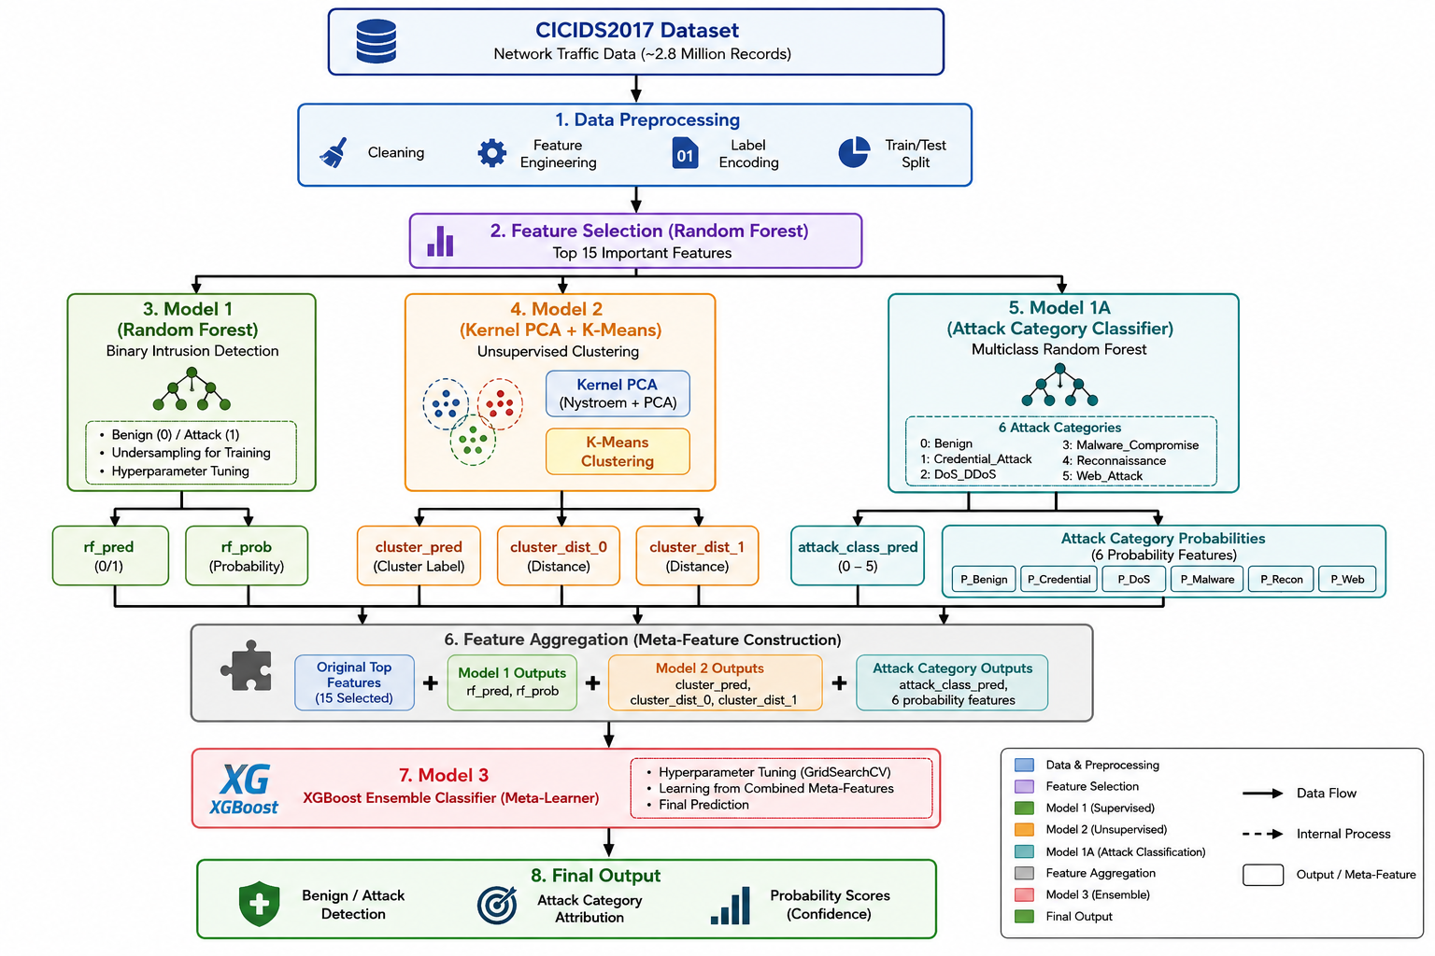
Fig 4: System Architecture of the Proposed Model

The proposed framework combines supervised, unsupervised, and ensemble learning techniques for network intrusion detection. Random Forest, Kernel PCA + K-Means, and a multiclass attack-category classifier generate complementary prediction and probability features, which are aggregated and provided to an XGBoost meta-learner. This hybrid architecture enables accurate attack detection, attack-family identification, and improved decision confidence.
4.1 MODEL 1: SUPERVISED LEARNING APPROACH(RANDOM FOREST)
4.1.1 SYSTEM OVERVIEW
Model 1 uses a supervised learning approach to classify network traffic as normal or malicious using labelled data. It follows a pipeline of preprocessing, feature engineering, training, and evaluation. A Random Forest classifier is applied on the CICIDS2017 dataset, with performance improved through feature selection, hyperparameter tuning, and evaluation.
4.1.1.1 Data Preparation
The dataset was split into features (X) and target (y), where Traffic_Label represents the binary class. A balanced training dataset was used to handle class imbalance and ensure fair learning across both classes.
4.1.1.2 Model Selection
A Random Forest classifier was chosen for its ability to handle high-dimensional data, resist overfitting, and provide feature importance. It was configured with random_state=42 for reproducibility and n_jobs=-1 for parallel processing.
4.1.1.3 Hyperparameter Tuning
Grid Search with 5-fold Stratified Cross-Validation identified optimal parameters: max_depth=20, min_samples_leaf=2, min_samples_split=5, and n_estimators=100. The top 15 features were selected based on random forest feature importance to improve efficiency and interpretability.
4.1.1.4 Model Retraining
The model was retrained using the selected top features, with X_train_top and X_test_top as the training and testing sets. This enables the model to focus on the most relevant information.
4.1.2 MODEL EVALUATION AND RESULTS
4.1.2.1 Classification Report
The model was evaluated using standard classification metrics, including accuracy, precision, recall, and F1-score. The results indicate strong overall performance, with an accuracy of approximately 99% and high precision and recall across both classes.
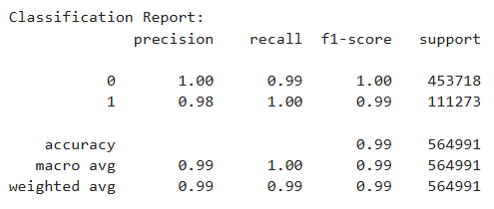
Fig 4.1.2.1: Classification Report (Supervised Model-Random Forest)

The model achieves strong and balanced performance with F1-scores of 0.99.
• Benign (Class 0): High precision (1.00) and recall (0.99) indicate accurate classification with minimal false positives. Attack (Class 1): Perfect recall (1.00) ensures almost all attacks are detected, with high precision (0.98).
Interpretation:
The model effectively distinguishes between normal and malicious traffic, maintaining a strong precision–recall balance, with high attack detection and improved efficiency through feature selection.

      - CONFUSION MATRIX ANALYSIS

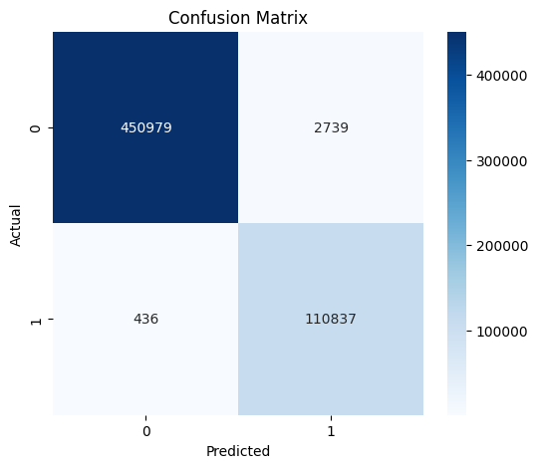
Fig 4.1.2.2: Confusion Matrix (Supervised Model-Random Forest)

The Random Forest model shows strong performance with high true negatives (450,979) and true positives (110,837), indicating effective detection of both benign and malicious traffic. False positives (2,739) are low, while false negatives (436) are minimal, ensuring most attacks are correctly identified.Overall, the model demonstrates reliable intrusion detection performance, with low misclassification rates and strong emphasis on detecting malicious activity.
      - ROC CURVE ANALYSIS
The ROC curve shows excellent model performance, with an AUC of 0.9996, indicating near-perfect class separation. The curve’s proximity to the top-left corner reflects a high true positive rate and low false positive rate. This confirms the model’s strong ability to distinguish between benign and malicious traffic, making it highly effective for intrusion detection, with further validation recommended for generalization.

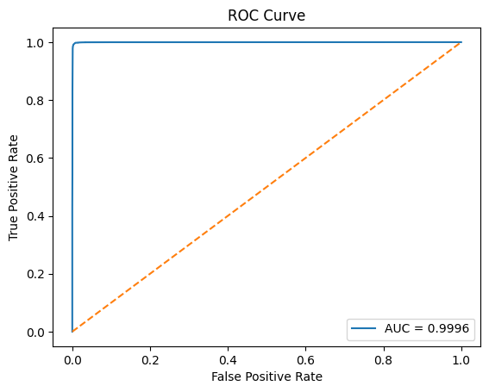
Fig 4.1.2.3: ROC Curve (Supervised Model--Random Forest)

      - FEATURE IMPORTANCE ANALYSIS
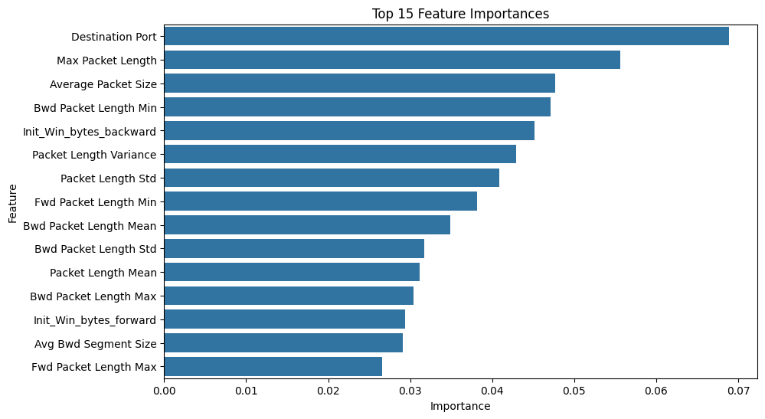
Fig 4.1.2.4: Top 15 Feature Importance (Supervised Model--Random Forest)

Random Forest feature importance identifies key features such as Destination Port, packet length metrics, and forward/backward traffic characteristics, along with TCP window size features for connection-level insights. Overall, traffic patterns are crucial for attack detection. Selecting top features improves efficiency, reduces dimensionality, and enhances interpretability while maintaining performance.

4.1.2.5 LEARNING CURVE ANALYSIS
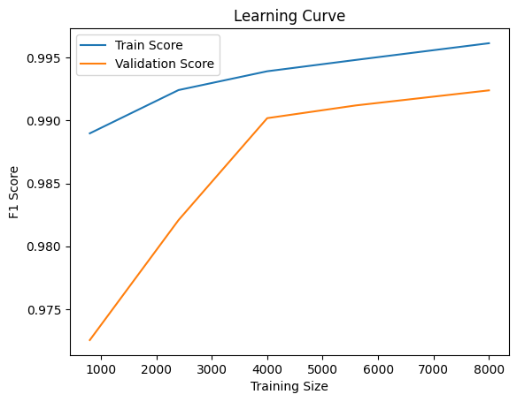
Fig 4.1.2.5: Learning Curve (Supervised Model--Random Forest)

The model shows strong performance, with training F1-score increasing from 0.989 to 0.996 and validation F1-score from 0.972 to 0.992 as data size grows. The small gap (~0.003–0.004) indicates minimal overfitting and good generalization, showing a stable and well-balanced model.

  - MODEL 1A : MULTICLASS ATTACK TYPE CLASSIFICATION USING RANDOM FOREST
4.2.1 SYSTEM OVERVIEW:
After developing a binary intrusion detection model to distinguish between benign and malicious traffic, a second supervised learning model was developed to identify the specific category of attack associated with each malicious network flow. The objective of this model is to classify network traffic into one of six attack categories. In addition to attack-type prediction, the class probabilities generated by the model are used as meta-features for the final ensemble model (Model 3).
4.2.2 METHODOLOGY
Fig 4.2.1.7: K-Means Clustering in PCA Space
4.2.2.1 Training Dataset
To ensure consistency with the binary Random Forest model, the same balanced training dataset was reused. The attack category labels corresponding to the selected training records were extracted. This guarantees that both binary and multiclass models are trained on identical network flows.
      - Feature Selection
The same top 15 features identified through Random Forest feature importance analysis were reused.
4.2.2.3 Random Forest Model
A multiclass Random Forest classifier was trained using 200 trees, maximum depth of 20, minimum split size of 5, and minimum leaf size of 2 (random_state=42). The model was designed to classify network traffic into six attack categories: Benign, Credential_Attack, DoS_DDoS, Malware_Compromise, Reconnaissance, and Web_Attack.
4.2.2.4 Attack Type Prediction
The trained model was evaluated on the unseen test dataset and generated an attack category prediction for every network flow. The predicted attack category (attack_class_pred) was stored as a meta-feature within the Model 3 dataset. It provides attack-family information in addition to binary attack detection. In addition to that, it enables the final ensemble model to understand the nature of the detected attack and improves contextual awareness during final classification.
4.2.2.5 Softmax-Style Probability Generation
Although Random Forest does not use a Softmax output layer internally, the predict_proba() function generates class-membership probabilities that behave similarly to Softmax probabilities. The model generated a probability matrix of size 564,991 × 6, representing the likelihood of each network flow belonging to one of the six attack categories. For example, a prediction of [0.98, 0.00, 0.01, 0.00, 0.01, 0.00] indicates a 98% probability of Benign traffic, with small probabilities assigned to DoS_DDoS and Reconnaissance categories.

4.2.2.6 Meta-Feature Generation for Model 3
The probability associated with each attack category was stored as a separate feature.
Generated Features- attack_prob_Benign, attack_prob_Credential_Attack, attack_prob_DoS_DDoS, attack_prob_Malware_Compromise, attack_prob_Reconnaissance and attack_prob_Web_Attack. These probability features provide richer information than a single predicted class and allow the final XGBoost model to utilize attack-category confidence scores during decision making.
4.2.2.7 Classification Performance
Classification Report
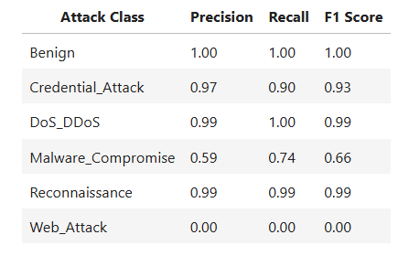

Overall Accuracy ~100% Weighted and F1 Score: ~1.00
Interpretation of Results
Attack Category Performance Analysis
Attack Category | Precision | Recall | F1 Score | Interpretation
Benign | 1.00 | 1.00 | 1.00 | The model perfectly distinguished benign traffic from attack traffic.
DoS_DDoS | 0.99 | 1.00 | 0.99 | Denial-of-Service attacks exhibited strong and distinctive traffic patterns, resulting in near-perfect classification.
Reconnaissance | 0.99 | 0.99 | 0.99 | Reconnaissance activities such as port scanning were highly separable from other attack categories.
Credential_Attack | 0.97 | 0.90 | 0.93 | The majority of brute-force authentication attacks were correctly identified.
Malware_Compromise | 0.59 | 0.74 | 0.66 | Performance was moderate due to the limited number of available training samples.
Web_Attack | 0.00 | 0.00 | 0.00 | The model failed to learn a reliable decision boundary because this category represented less than 0.02% of the dataset.
Overall Accuracy: ~100%
Weighted F1 Score: ~1.00
4.2.2.8 Confusion Matrix Analysis
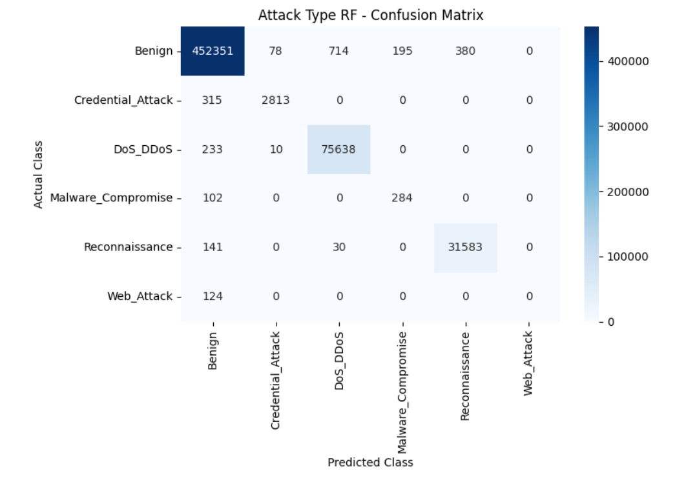
The confusion matrix demonstrates strong multiclass classification performance, with most Benign, DoS_DDoS, Reconnaissance, and Credential_Attack samples correctly identified. Misclassifications were mainly concentrated in the Malware_Compromise and Web_Attack categories due to their limited sample sizes, highlighting the impact of class imbalance on minority attack classes.4.2.2.9 ROC – AUC Curve Analysis
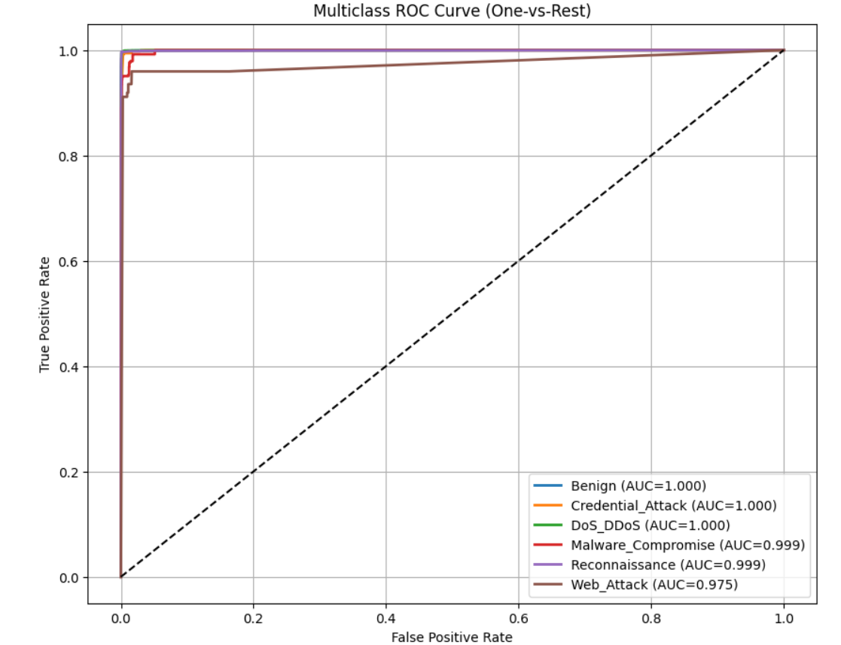
A One-vs-Rest (OvR) ROC analysis showed excellent performance across all attack categories, with AUC values ranging from 0.975 to 1.000. Even the minority Web_Attack class achieved an AUC of 0.975, indicating strong class separability and reliable probability estimation despite severe class imbalance.
4.2.2.10 Learning Curve Analysis
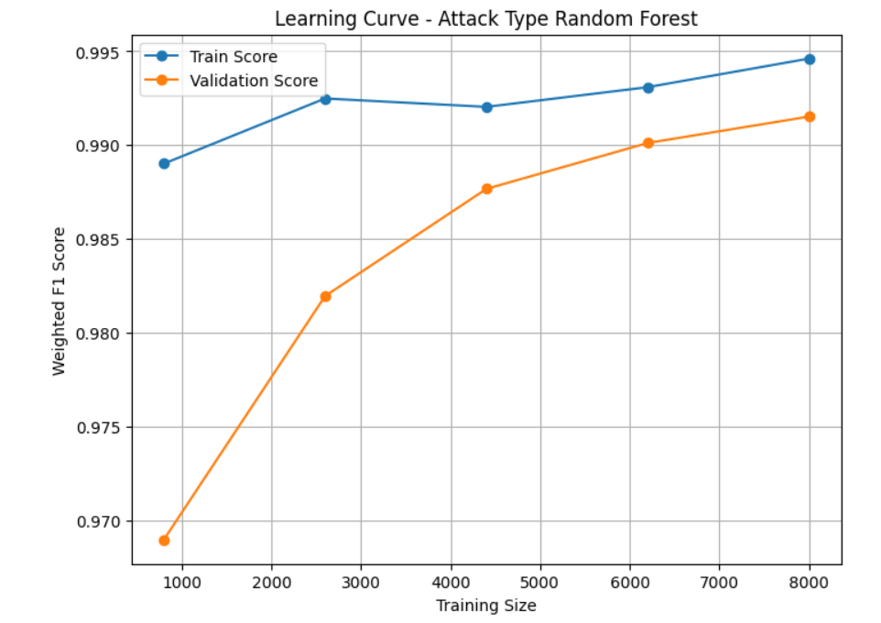
The learning curve demonstrates strong generalization performance, with the training and validation F1 scores converging at approximately 0.995 and 0.992, respectively. The close alignment between the two curves indicates minimal overfitting and low model variance. Furthermore, validation performance improves consistently as additional training samples are introduced, suggesting that the model effectively learns underlying attack patterns and maintains robust performance on unseen data.
4.2.3 Conclusion
The multiclass Random Forest model achieved excellent performance in identifying major attack categories, particularly Benign, DoS_DDoS, and Reconnaissance traffic, while demonstrating strong generalization and minimal overfitting. Although Malware_Compromise and Web_Attack remained challenging due to severe class imbalance, the model successfully generated attack-category predictions and probability scores. These outputs were integrated into Model 3 alongside binary Random Forest predictions and Kernel PCA + K-Means clustering features, providing valuable attack-type intelligence that enhanced the final XGBoost ensemble model's detection accuracy and robustness.

4.3 UNSUPERVISED FEATURE ENGINEERING USING K-MEANS CLUSTERING
4.3.1 SYSTEM OVERVIEW
The goal of this step is to extract additional informative features from the dataset using an unsupervised learning approach. Specifically, we use K-Means clustering to identify inherent patterns in the data and convert them into new features that can improve downstream supervised models.
      - Balanced Sampling for Unsupervised Learning
In order to mitigate class imbalance, a balanced dataset was created by randomly selecting 50,000 benign and 50,000 attack samples. The combined dataset was then shuffled to ensure that K-Means learns representative patterns from both classes equally.
      - Data Preparation
The dataset is split into: Features (X_train_unsup) Labels (y_train_unsup). The same test set used in supervised learning is reused for consistency.
      - Feature Scaling
Standardization is applied using StandardScaler to normalize the feature space. This is important because: K-Means is distance-based . Features with larger scales would otherwise dominate clustering.
      - Dimensionality Reduction using PCA
PCA reduced the feature space from 77 to 20 features, removing noise and redundancy while improving clustering efficiency and reducing computational complexity.
      - K-Means Clustering
MiniBatch K-Means was applied with 2 clusters, a batch size of 5,000, and 10 initialization runs. This approach was selected for its computational efficiency and ability to scale effectively to large network traffic datasets while maintaining clustering performance.
4.3.1.6 Cluster Interpretation
Since K-Means is an unsupervised algorithm, the generated cluster labels do not directly represent benign or attack traffic. To assign meaning to each cluster, the average attack rate within each cluster was calculated. Cluster 0 had an attack rate of 40.15% and was mapped to Benign, while Cluster 1 had an attack rate of 87.77% and was mapped to Attack. This mapping indicates that Cluster 1 predominantly contains malicious traffic, whereas Cluster 0 primarily represents benign network flows.
4.3.1.7 Feature Engineering from Clustering
Three clustering-based features were generated: cluster_pred, cluster_dist_0, and cluster_dist_1. These features capture cluster assignments and distances to cluster centroids, providing additional structural information that enhances the final ensemble model's classification capability.
4.3.1.8 Integration into Final Dataset
The clustering-derived features (cluster_pred, cluster_dist_0, and cluster_dist_1) were added to the final dataset alongside the original features and Random Forest outputs (rf_pred and rf_prob). This transforms unsupervised clustering information into useful meta-features for the hybrid ensemble model.
4.3.1.9 Conclusion
K-Means clustering successfully identifies underlying structure in the network traffic data. By converting cluster assignments and distances into features, we enhance the model's ability to distinguish between benign and malicious traffic. This step plays a crucial role in improving the performance of the final classification model.
4.3.2 Visualization of K-Means Clustering in PCA Space
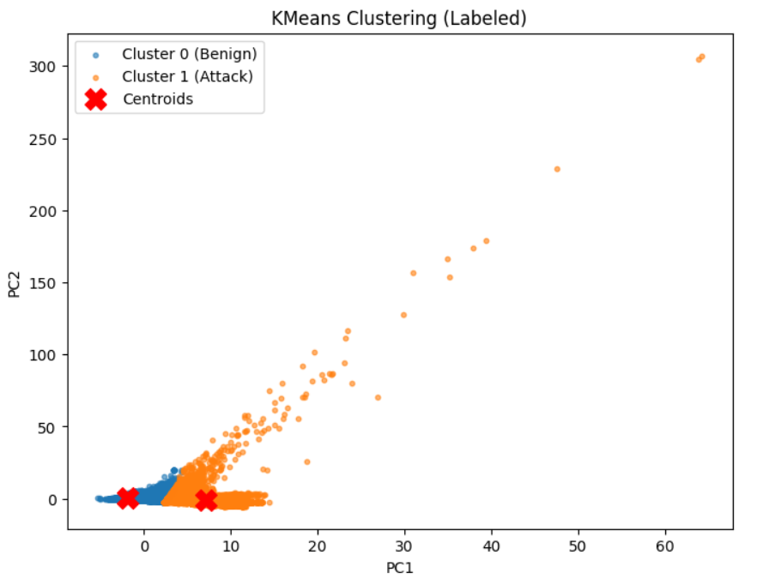

The PCA visualization showed that benign traffic formed a compact cluster, while attack traffic was more dispersed, indicating greater behavioral variability. Despite some overlap, the clusters exhibited clear separation, demonstrating that K-Means captured meaningful patterns in the network traffic data.
4.3.3 Evaluation and Role of K-Means Clustering
This provides as a baseline to compare with Kernel PCA + K-means
4.3.3.1 Objective
The purpose of this evaluation is to assess the performance of the K-Means clustering model and understand its contribution within the overall hybrid machine learning pipeline. Although K-Means is an unsupervised learning algorithm, its performance can be evaluated by comparing cluster assignments with true labels.
4.3.3.2 Performance Summary
i. Classification Metrics
- Accuracy: 0.83 Macro F1-score: 0.68 Weighted F1-score: 0.82
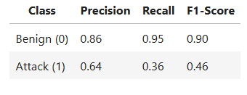
ii. Confusion Matrix Analysis
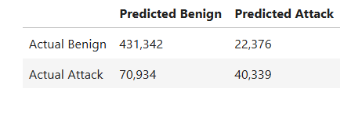
The model performs very well in identifying benign traffic (high true negatives). A significant number of attack samples are misclassified as benign (high false negatives). This indicates that attack patterns are not well captured by clustering alone.
iii. ROC Curve Analysis
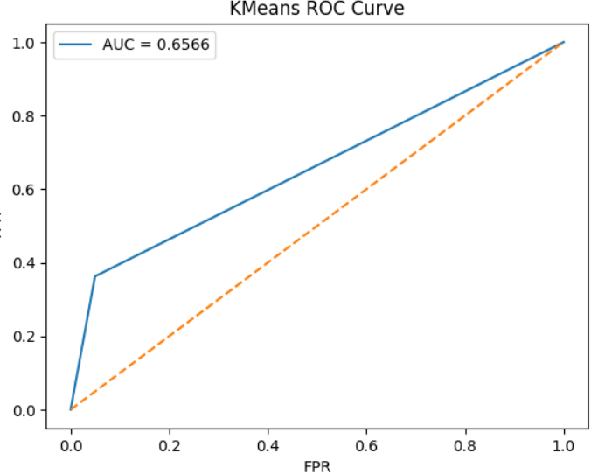
AUC Score: 0.6566
The model performs better than random guessing (AUC = 0.5). However, the discrimination capability is limited. This confirms that K-Means is not suitable as a standalone classifier.
iv. Classification report
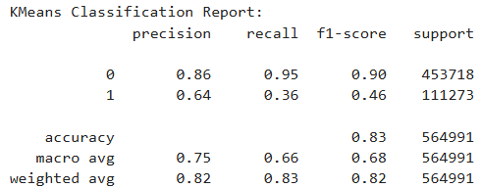
K-Means achieved an overall accuracy of 83%, performing well on benign traffic detection but showing lower recall (36%) for attack traffic, indicating difficulty in identifying malicious network activity.
v. Confusion Matrix
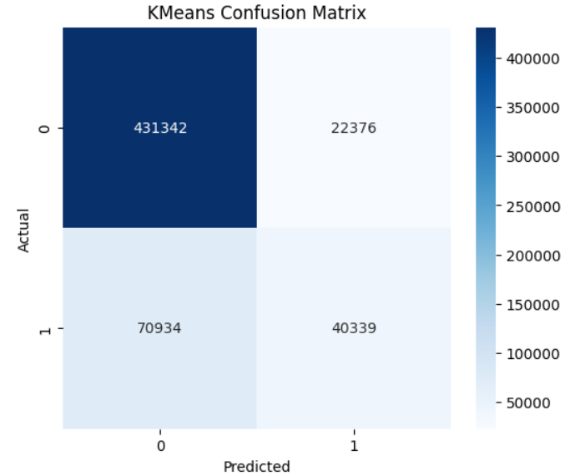
The K-Means model achieved a Silhouette Score of 0.4893, indicating moderate cluster separation, with strong benign traffic detection but a high number of attack instances misclassified as benign.
4.4 Model 2 : Unsupervised Learning Model: Kernel PCA + K-Means Clustering
4.4.1 Objective
The objective of this unsupervised learning model was to identify latent patterns in network traffic without using class labels during the clustering process. Unlike supervised learning approaches such as Random Forest, which rely on known attack labels, this model attempts to discover natural groupings within the CICIDS2017 dataset and subsequently map those clusters to benign and malicious traffic. The output of this model is later used as a meta-feature in the final ensemble model (Model 3), where the clustering predictions and cluster distance metrics are combined with supervised model outputs.
4.4.2 Methodology
4.4.2.1 Feature Selection
The top 15 most important features identified using Random Forest feature importance were selected to focus clustering on the most informative network traffic characteristics.
4.4.2.2 Dataset Preparation
A balanced dataset was created by randomly sampling 10,000 benign and 10,000 attack records, resulting in 20,000 network flows. This prevents cluster formation from being biased toward the majority benign class.
4.4.2.3 Feature Standardization
All selected features were standardized using StandardScaler to ensure each feature has a mean of 0 and standard deviation of 1, preventing features with larger values from dominating the clustering process.
4.4.2.4 Non-Linear Feature Transformation
To capture complex non-linear attack patterns, an RBF kernel was approximated using the Nystroem method (gamma = 0.01, n_components = 500). This approach improves cluster separability while remaining computationally efficient for large datasets.
4.4.2.5 Dimensionality Reduction
PCA was applied to reduce the transformed 500-dimensional feature space to 10 principal components, reducing noise and computational complexity while retaining the most significant information.
4.4.2.6 K-Means Clustering
K-Means clustering was performed on the reduced feature space. The algorithm iteratively assigns data points to the nearest cluster centroid and updates centroids until convergence, aiming to maximize cluster separation and minimize within-cluster variance.
4.4.3 Determination of Optimal Number of Clusters
The optimal number of clusters was selected using the Elbow Method and Silhouette Analysis. Since no clear elbow point was observed, the silhouette score was used, with k = 2 achieving the highest score (0.5823). Therefore, two clusters were selected.
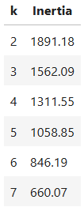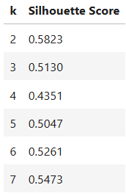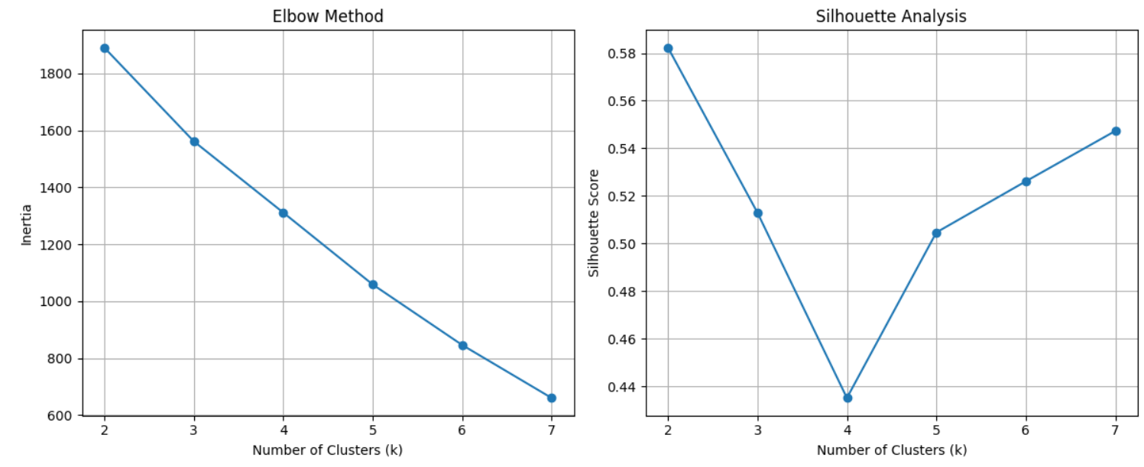

4.4.4 Cluster Interpretation
Clusters were labeled based on their attack rates. Cluster 0 was assigned as Benign, while Cluster 1 was assigned as Attack. 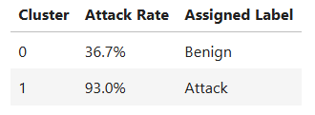
4.4.5 Cluster Visualization
Kernel PCA visualization showed improved separation between benign and attack traffic, with minimal overlap between clusters, indicating effective capture of non-linear patterns.
4.5 Classification Performance
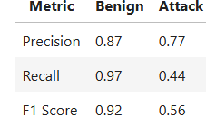
The Kernel PCA + K-Means model achieved 86% accuracy with strong benign traffic detection and moderate attack detection performance. The improvement in attack F1-score 0.56 indicates that the non-linear transformation enhanced cluster quality and attack identification.
Confusion Matrix Analysis
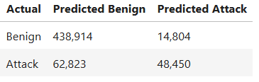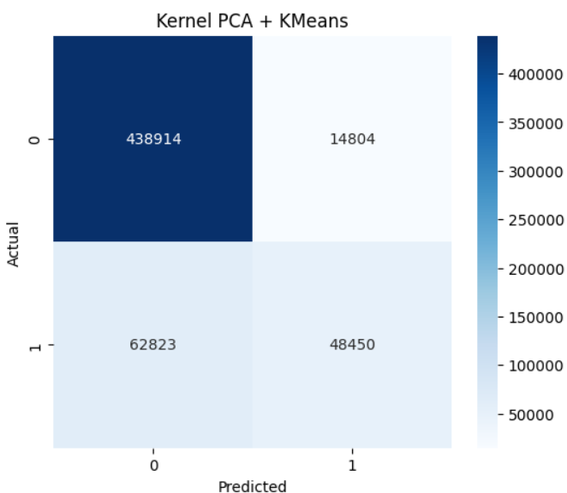
The confusion matrix shows that the model correctly classified most benign traffic while detecting a substantial portion of attack traffic. However, some attacks were still misclassified as benign, resulting in lower attack recall.
ROC-AUC Analysis
The model achieved an AUC of 0.6967, indicating moderate discrimination between benign and malicious traffic and performance significantly better than random guessing. 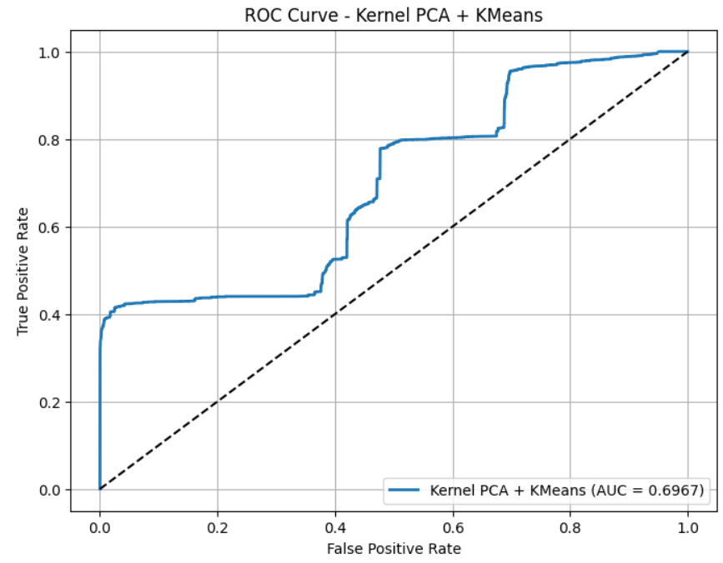
Key Findings
The model achieved 86% overall accuracy and a Silhouette Score of 0.5823, demonstrating well-separated clusters and reduced overlap between benign and attack traffic. Additionally, the clustering process generated meaningful meta-features that enhanced the final ensemble model. However, the model achieved only 44% attack recall, indicating that some attack samples remained embedded within benign clusters, resulting in lower performance than the supervised learning models.
Role in the Hybrid Framework
The clustering model contributes additional unsupervised information to the final XGBoost ensemble through cluster assignments and distance-based features, complementing the supervised Random Forest predictions.

Comparative Analysis: PCA + K-Means vs Kernel PCA + K-Means
The objective was to evaluate whether a non-linear Kernel PCA transformation improves K-Means clustering performance compared to traditional PCA.
Clustering Quality
Kernel PCA achieved a higher Silhouette Score (0.5823 vs 0.4893), indicating better cluster cohesion and separation. The Kernel PCA approach improved the silhouette score by approximately 19%.
Classification Performance
Kernel PCA improved overall accuracy, attack precision, attack recall, F1-score, and ROC-AUC compared to the PCA-based model. Kernel PCA improved overall classification accuracy by approximately 3.6%, attack precision by 20.3%, attack recall by 22.2% and F1 score by 21.7%.
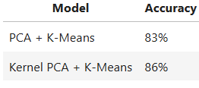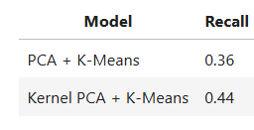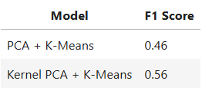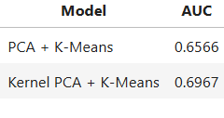
Confusion Matrix Comparison
The Kernel PCA model detected more attack samples while simultaneously reducing false positives, demonstrating improved intrusion detection capability.
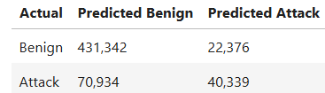
PCA + K-Means
Attack Detection Rate:
40,339 / 111,273 = 36.3%

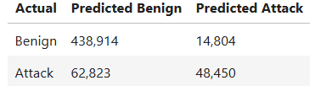
Kernel PCA + K-Means Attack Detection Rate:
48,450 / 111,273 = 43.5%

The Kernel PCA model successfully identified 8,111 additional attack samples that were missed by the PCA-based clustering model.
False positives reduced from: 22,376 → 14,804
Reduction achieved: 22,376 - 14,804 = 7,572 fewer false alarms. This demonstrates that Kernel PCA simultaneously improved attack detection while reducing false alerts.

Visual Cluster Separation
Compared to traditional PCA, Kernel PCA produced clearer cluster separation, more compact cluster structures, and reduced overlap between benign and attack traffic. These visual improvements are consistent with the higher silhouette score, improved attack recall, and increased AUC achieved by the Kernel PCA + K-Means model.
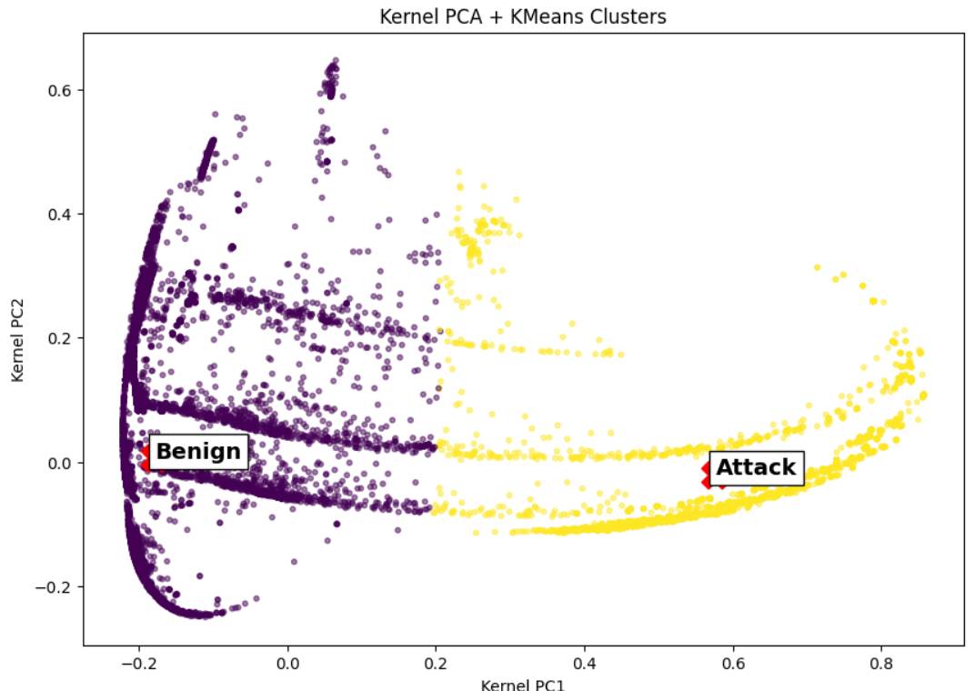

Overall Findings
Kernel PCA consistently outperformed traditional PCA across all evaluation metrics, producing better cluster separation and more effective attack detection.
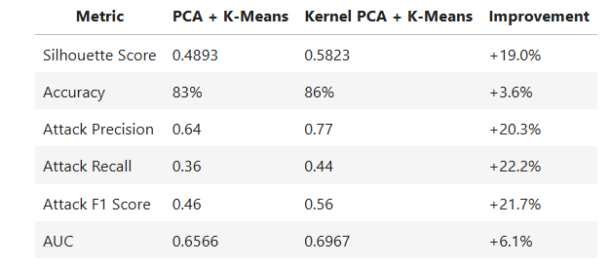
Conclusion
Kernel PCA significantly enhanced K-Means clustering by capturing non-linear relationships within network traffic data. The resulting model achieved better clustering quality, improved attack detection, fewer false alarms, and stronger overall performance than the PCA-based approach.
Consolidate output from Model 1 (Random Forest) , Model 2 (Random Forest Softmax) , Model 3 (Kernal PCA + K-Means) which goes to final XGBoost Model
4.5 Model 3: Final Hybrid Ensemble Model: Integration of Supervised, Unsupervised, and Attack-Type Intelligence
4.5.1 Objective
The objective of the final hybrid model is to combine insights from multiple learning approaches into a unified intrusion detection framework. The model integrates binary intrusion predictions from Random Forest, attack-category predictions and probabilities from a multiclass Random Forest, structural information derived from Kernel PCA + K-Means clustering, and original network traffic features. These complementary features are then provided to an XGBoost classifier, which serves as the final decision-making model for detecting malicious network activity.
4.5.2 Hybrid Architecture
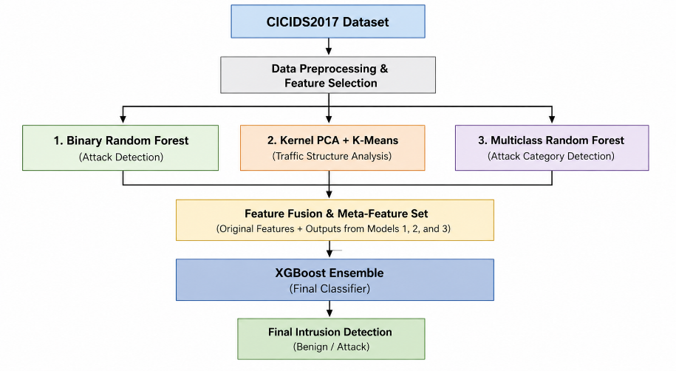

4.5.3 Feature Preparation
The final dataset was constructed using the original CICIDS2017 traffic features together with outputs generated by the preceding models. The Binary Random Forest contributed rf_pred and rf_prob, representing the predicted traffic class and attack probability. The Attack-Type Random Forest provided attack_class_pred along with six attack-category probability features: attack_prob_Benign, attack_prob_Credential_Attack,attack_prob_DoS_DDoS,attack_prob_Malware_Compromise, attack_prob_Reconnaissance, and attack_prob_Web_Attack. The Kernel PCA + K-Means model contributed cluster_pred, cluster_dist_0, and cluster_dist_1, capturing cluster membership and distance from cluster centroids. These features were combined with the original network traffic attributes to create a rich feature set for the final XGBoost ensemble model.
4.5.4 Feature Selection and Data Splitting
To preserve information from all three learning paradigms, a set of 12 mandatory features was retained in the final dataset, including Binary Random Forest outputs (rf_pred, rf_prob), Attack-Type Random Forest outputs (attack_class_pred and six attack_prob_* features), and Kernel PCA + K-Means outputs (cluster_pred, cluster_dist_0, cluster_dist_1). A Random Forest model (100 trees, random_state=42) was then used to compute feature importance scores, and the top 20 features were selected. These top-ranked features were merged with the mandatory features to reduce dimensionality while preserving all ensemble signals.
The resulting feature set was split into 80% training and 20% testing data using a stratified train-test split (random_state=42), ensuring that the class distribution remained consistent across both datasets.
4.5.5 Final Classifier: XGBoost
The final ensemble model utilized XGBoost (objective="binary:logistic", eval_metric="logloss") to integrate supervised, unsupervised, and attack-category intelligence. Hyperparameters were optimized using GridSearchCV with 3-fold cross-validation and ROC-AUC scoring. A total of 16 parameter combinations (48 model fits) were evaluated across n_estimators (100, 200), max_depth (4, 6), learning_rate (0.05, 0.10), and subsample (0.8, 1.0).
Best Hyperparameters: n_estimators=200, max_depth=6, learning_rate=0.10, and subsample=0.80. This configuration provided an effective balance between predictive performance, model complexity, and generalization.

4.5.6 Hybrid Architecture Advantages
The proposed framework differs from traditional intrusion detection systems by combining binary intrusion detection, attack-type classification, and unsupervised clustering intelligence within a single ensemble architecture. The Binary Random Forest contributes rf_pred and rf_prob, the multiclass Random Forest provides attack_class_pred and attack_prob_* features, while Kernel PCA + K-Means contributes cluster_pred, cluster_dist_0, and cluster_dist_1.
This integration enables the model to simultaneously capture network traffic characteristics, attack likelihood, attack-category confidence, and latent cluster structure. By combining complementary information from multiple learning paradigms, the ensemble improves generalization, reduces reliance on any single model, and enhances robustness against diverse attack patterns.
Final Feature Categories
Feature Group | Purpose
Original Network Features | Traffic characteristics
rf_pred, rf_prob | Binary attack intelligence
attack_class_pred, attack_prob_* | Attack-category intelligence
cluster_pred, cluster_dist_* | Clustering-based structural information
Conclusion
The final model integrates Random Forest binary predictions, attack-type probabilities, Kernel PCA + K-Means clustering features, and original network traffic attributes into a unified XGBoost ensemble. By learning from these complementary information sources, the proposed hybrid architecture provides a richer representation of network behavior and delivers improved intrusion detection performance, generalization, and robustness compared to standalone approaches.
4.5.7 Evaluation and Analysis
1. Classification Performance
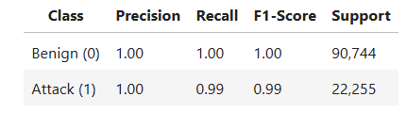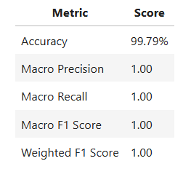
Classification Report

Overall Performance

The final hybrid model achieved near-perfect performance, accurately distinguishing between benign and malicious traffic with extremely high precision and recall. The results demonstrate that combining binary predictions, attack-type intelligence, and clustering-based features significantly improves intrusion detection effectiveness and robustness.
2. Confusion Matrix Analysis
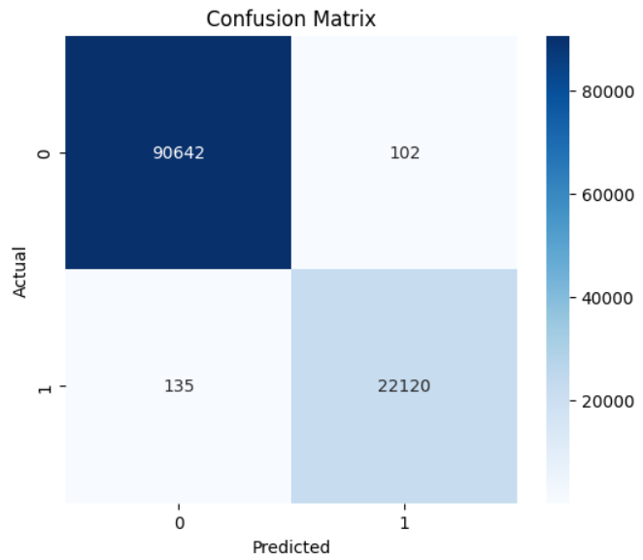
The confusion matrix demonstrates excellent class separation, with 90,642 true negatives and 22,120 true positives correctly classified. The model produced only 102 false positives (0.11%) and 135 false negatives (0.61%), indicating a very low false alarm rate while successfully detecting the vast majority of attacks. These results highlight the model's reliability and effectiveness for intrusion detection applications.
3. ROC-AUC Analysis
The model achieved an AUC score of 0.9998, indicating near-perfect discriminative capability between benign and malicious traffic. The ROC curve closely follows the upper-left boundary, demonstrating extremely high sensitivity and specificity, with the model effectively distinguishing attacks from normal network activity.
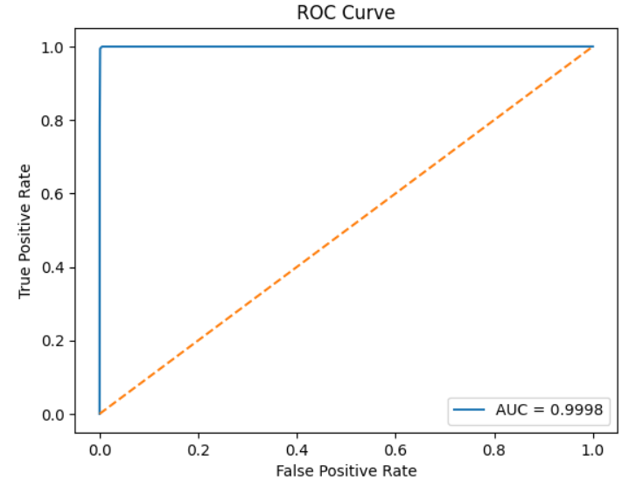
4. Learning Curve Analysis
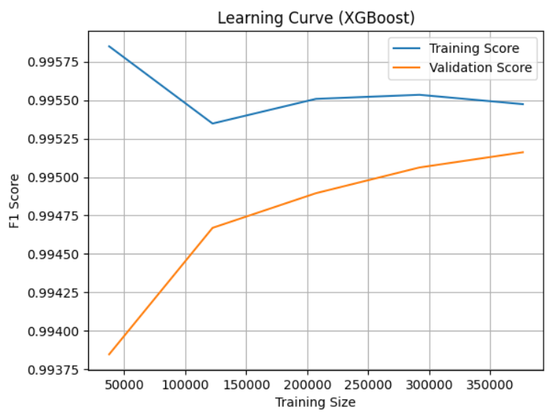
The learning curve demonstrates strong and stable model performance, with training F1 scores ranging from 0.9954 to 0.9958 and validation F1 scores ranging from 0.9938 to 0.9952. The small gap between the curves indicates minimal overfitting, while the steady improvement in validation performance with increasing training data suggests good generalization. Overall, the model exhibits stable learning behavior and sufficient complexity to effectively capture network intrusion patterns.
5. Feature Importance Analysis
The feature importance results show that attack_prob_Benign and rf_prob were the most influential predictors, highlighting the strong contribution of both the attack-type and binary Random Forest models. Clustering features (cluster_dist_0 and cluster_dist_1) also ranked among the important features, demonstrating that the Kernel PCA + K-Means model provided valuable structural information. Additionally, several original network traffic features, including Packet Length Std, Packet Length Mean, Max Packet Length, Average Packet Size, Subflow Fwd Bytes, and Bwd Packet Length Std, remained highly relevant, indicating that the ensemble effectively leverages both learned model outputs and raw traffic characteristics.

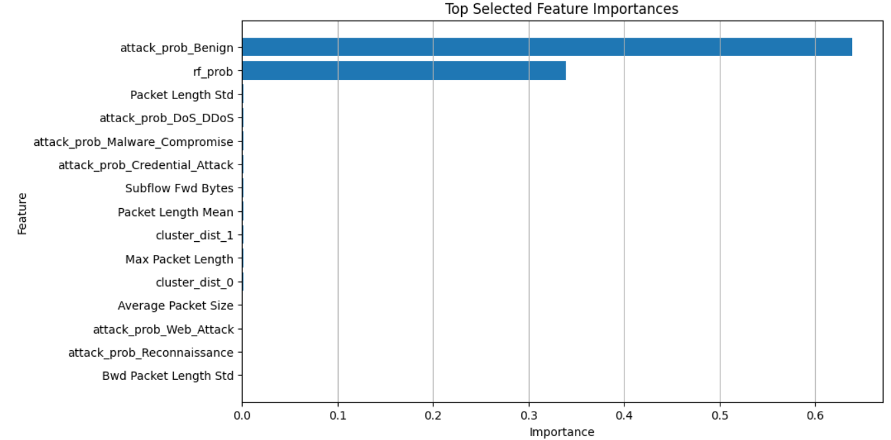
6. Overall Assessment and Conclusion
The feature importance analysis confirms successful integration of all components of the hybrid framework, including binary Random Forest outputs (rf_prob), attack-type probabilities (attack_prob_*), Kernel PCA + K-Means clustering features (cluster_dist_0, cluster_dist_1), and original network traffic features such as Packet Length statistics and Subflow Fwd Bytes. This demonstrates that the model effectively combines behavioral, attack-type, structural, and raw traffic information within a unified decision-making process.
The final XGBoost ensemble achieved 99.79% accuracy, 0.9998 ROC-AUC, 1.00 attack precision, 0.99 attack recall, and 0.99 attack F1-score, while maintaining a 0.11% false positive rate and 0.61% false negative rate. Learning curve analysis further indicated strong generalization and minimal overfitting. These results demonstrate that the proposed hybrid architecture provides a highly accurate, robust, and scalable solution for network intrusion detection.
7. Deployment Strategy
The proposed hybrid intrusion detection system is designed for real-time deployment, where network flows are captured, pre-processed, and analyzed using the Binary Random Forest, Kernel PCA + K-Means, and Multiclass Random Forest models. The generated meta-features are then aggregated and processed by the XGBoost ensemble to produce the final intrusion and attack-category prediction.
The system can be deployed as a REST API using FastAPI or Flask on on-premise servers, virtual machines, Docker containers, or cloud platforms such as AWS, Azure, and GCP. Due to the computational efficiency of Random Forest, XGBoost, and K-Means inference, the solution offers low latency, moderate deployment cost, and near real-time performance without requiring GPU resources. Periodic monitoring and retraining are recommended to address concept drift and maintain detection accuracy.
Limitations and Future Scope
Despite achieving excellent performance, the proposed hybrid framework has several limitations. The model relies heavily on meta-features generated by upstream models, introducing potential risks of data leakage and error propagation. The ensemble architecture is also computationally complex and less interpretable than standalone models. In addition, severe class imbalance affected minority attack categories such as Web_Attack and Malware_Compromise, while the model's generalization to zero-day attacks, emerging threats, and environments beyond the CICIDS2017 dataset remains unverified. Furthermore, the near-perfect performance (Accuracy ≈ 99.8%, AUC ≈ 0.9998) requires validation on external datasets to confirm real-world robustness.
Future work will focus on implementing a leakage-free stacking framework, evaluating advanced ensemble methods such as LightGBM and CatBoost, and exploring deep learning approaches including Autoencoders, LSTMs, and Transformers. Additional research will target real-time deployment, explainable AI techniques, improved detection of rare attack categories, concept drift adaptation, graph-based network
7. REFERENCES

[1] I. Sharafaldin, A. H. Lashkari, and A. A. Ghorbani, “Toward Generating a New Intrusion Detection Dataset and Intrusion Traffic Characterization,” Proceedings of the 4th International Conference on Information Systems Security and Privacy (ICISSP), pp. 108–116, 2018.
[2] S. Chavan, P. Patil, and R. Deshmukh, “Intrusion Detection on CICIDS2017 Using Random Forest,” International Journal of Computer Applications (IJCA), vol. 187, no. 12, pp. 15–22, 2025.
[3] M. Alzahrani, A. Alshamrani, and M. Aldossary, “Hybrid Clustering-Based Intrusion Detection System Using Machine Learning Techniques,” arXiv preprint arXiv:2208.09711, 2022.
[4] X. Zhang, Y. Wang, and H. Liu, “Network Intrusion Detection Based on XGBoost Machine Learning Algorithm,” Computers & Security, vol. 138, 2024.
[5] A. Verma, S. Gupta, and R. Kumar, “Stacking-Based Ensemble Learning for Network Intrusion Detection,” arXiv preprint arXiv:2003.08585, 2020.
[6] S. Aljawarneh, M. Aldwairi, and M. B. Yassein, “PCA-Based Feature Reduction for Efficient Intrusion Detection Systems,” Applied Sciences (MDPI), vol. 13, no. 4, 2023.
[7] D. Novakovic, N. Jovanovic, and M. Radovanovic, “Hybrid Feature Selection Techniques for Intrusion Detection Systems,” Informatica, vol. 47, no. 3, pp. 401–412, 2023.
[8] B. Schölkopf, A. Smola, and K. R. Müller, “Kernel Principal Component Analysis,” Proceedings of the 7th International Conference on Artificial Neural Networks (ICANN), pp. 583–588, 1997.
[9] M. A. Ferrag, L. Maglaras, H. Janicke, J. Jiang, and M. Shu, “A Systematic Review of Data Mining and Machine Learning for Cyber Security Intrusion Detection,” IEEE Communications Surveys & Tutorials, vol. 24, no. 1, pp. 442–485, 2022.
[10] T. G. Dietterich, “Ensemble Methods in Machine Learning,” Multiple Classifier Systems, Lecture Notes in Computer Science, vol. 1857, Springer, pp. 1–15, 2000.

